Category-Informative
Keyword-MS Backup(.bkf) Error Recovery

Keywords:
create backup disc windows 10, backup recovery solutions, best backup solutions, backup solutions for business, data center backup solutions, ms backup error recovery, windows data recovery software, ms backup software, ms backup and restore, microsoft backup error assistant, microsoft backup error restore, reasons of backup failure, need for backup file recovery, data backup recovery failure, repair a corrupt BKF file, WindowsNT Repair,

MS Backup(.bkf) Error Recovery

In this world of technology, users save all their important data on personal computers and laptops. Data can either be in the form of multimedia, documents, and emails etc. Therefore, it is crucial to keep a backup of all data in case the computer crashes and all data is lost. Users can create a backup through Windows backup, or another tool. This backup can be used to restore the lost data. However, sometimes backup files get corrupted. Therefore, in this blog, we will elaborate the approaches to MS Backup (.bkf) error recovery.
Windows Backup provides users with the ability to create a system backup. The system image includes Windows OS, programs, files and system settings. This system image can restore the contents of the computer if a hard drive or computer ever stops working.

Need for Backup(BKF) File Recovery
Sometimes, the backup file can get damaged often because they are saved in the local hard disk. When they are not protected by System Restore, corruption may occur due to registry corruption, software failure, etc. Further reasons could be backup interruption, sudden system shut-down, unrecognised media, etc. System backups are a means of restoring data to a computer that has stopped working. Since system restore depends entirely on the backup file. It is very important for the user, to repair the corrupt BKF file.

Methods of BKF Recovery
The backup of a corrupt data file is crucial to the restoration process. The users can try to repair a corrupt BKF file by using WindowsNT Repair. It can repair .bkf files created with Veritas software for Windows NTBackup or Backup Exec. The steps are as follows:
- Open the folder containing NTBackup.exe. Right click<<Run as Administrator.
- NTBackup shows the message “Removable Storage service (removed in Windows Vista & higher)”. This is only required for tape backups. Click OK.
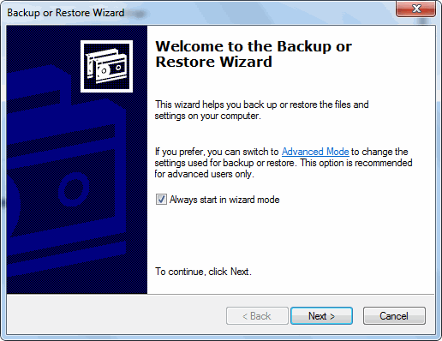

- A new window “Welcome to Backup or Restore Wizard” will open. Click Next.
- Select Restore files and settings>>Next.
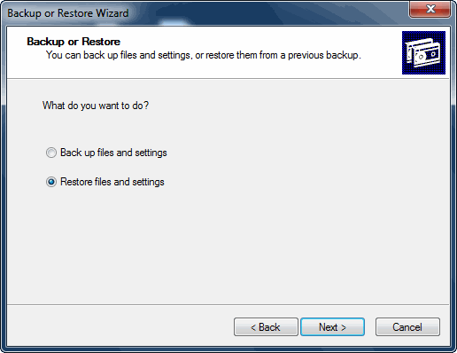

- Click Browse. Select the .BKF file to restore. Click OK.

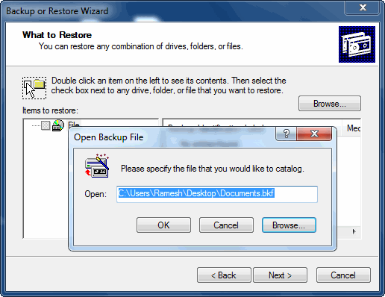

- Expand from the left pane and select the desired files/folders>>Next.
- Click the Advanced button.
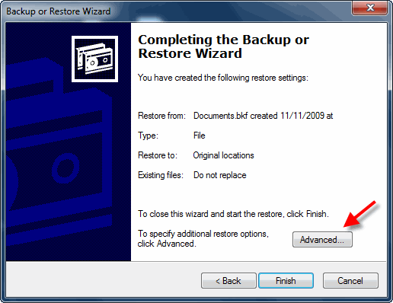

- Under “Restore files to” drop-down, select Alternate location. Specify the destination path.
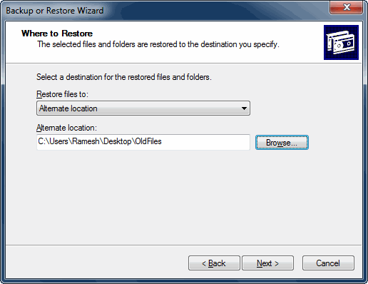

- Accordingly select the restore options.
- Click Next>>Finish
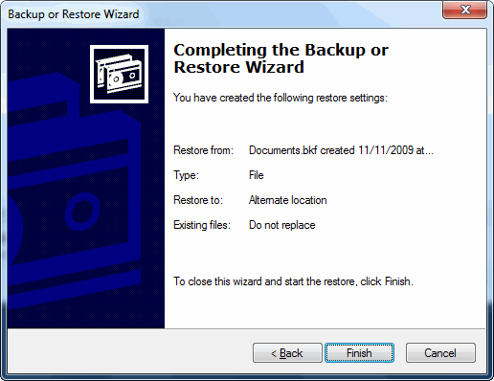

In this manner, some backup files can be repaired. It is important to note that the Windows Restore Process is successful in some cases. At times when the file has major corruption, this process does not fully repair the files.

Limitations of the Manual Method
The following limitations are observed in the backup recovery solutions of WindowsNT Repair:
- MS backup error recovery only works for Windows Vista, Windows 7 and 8. It is not applicable to Windows XP or older versions. It is a lengthy and time-consuming process.
- This method may result in some data loss. This is not ideal because the users wants all files of the backup to be intact.
- It will work only if the necessary DLL files are present in the system. These files, i.e. ntmsapi.dll and vssapi.dll need to be present.

Trouble-free Solution
Owing to the limitations of the manual method, it is better to opt for a software like Backup Recovery Tool. This standalone utility can open and repair corrupt BKF backup files. It has two scan modes, one for healthy files and the other for corrupt files. The tool generates a preview of all files. There is no data loss during recovery which makes it a good alternative to the manual method.

Conclusion
Nowadays, users save a backup of all their data. This comes in handy in case the computer stops working, or a drive is wiped clean. Often times, this very BKF backup file gets corrupted because of a software failure or human error. Therefore, it becomes very important to recover this corrupted backup file. In this blog, we discussed the MS Backup (.bkf) error recovery technique using WindowsNT Repair. But, users have observed data loss using this method. So, it is advised to use a third-party utility like the Backup Recovery Tool. The toolis compatible with all versions of Windows OS and can open and repair damaged BKF backup files.

